Jan 2017

Hi,  
HAPPY NEW YEAR !!!  
Hope that 2016 was good to you & yours and that 2017 would be a fantastic year.

<https://www.youtube.com/watch?v=eB6gUfaDz9w>

**THANKS:**  
We thank you sincerely for all of the holiday greetings and expressions of sympathy  
on the passing of Baldwin's brother, Horace. So very kind of you. Much appreciated.  
  
**ST. PAUL'S AND ST. JOHN'S:**   
Theme for the Anniversary of  St. Paul's 175 Years 2015–dodransbicentennial celebration  **175 Years– We Remember, Renew, Reach Out**  
  
Visit St. Paul's Anglican Church, Calliaqua, St. Vincent, Website at:   
[http://stpaulscalliaqua.homestead.com](http://stpaulscalliaqua.homestead.com/)  
See bulletin:

WELCOME TO ST.  PAUL'S AND ST.JOHN'S: The Rev'd Canon Ashton Francis

From the Bishop’s Desk 18th Dec. 2016

Appointment

I have appointed the Rev'd Canon Ashton Francis as Rector of the Parish of St. Paul, Calliaqua with St. John, Belair, St. Vincent and the Grenadines with effect from 1st January, 2017. The service of Institution, and Induction is scheduled for 5:00pm on Tuesday 2nd May, 2017 at the St. Paul's Parish Church, Calliaqua.

**ASSISTANCE:**

I am asking each parish to have an appeal for assistance for the people of Sandy Bay, St. Vincent and the Grenadines who were affected after the recent passing of the trough system in November, 2016. The Rev'd Fr. Kari Marcelle has informed me that the present need is for clothing, bottled water (this is essential, as some of the water is still contaminated) and or non - perishable items. Some of them have lost their house and belongings. So there may also be the need for financial assistance.

You may choose to give cash or kind. Parishes may choose to purchase bottle water and accumulate clothing and other items. You may deliver cash or kind directly to The Parish of the Holy Trinity C/0 Fr.

Kari Marcelle or to Diocesan Office.   
  
E-Mail: [stpaulschurch@vincysurf.com](mailto:stpaulschurch@vincysurf.com)  
             [parishstpaulschurch@gmail.com](mailto:parishstpaulschurch@gmail.com)

If you wish to sponsor the Church Bulletin, please call  the Church Office at 457-5163

We extend a warm welcome to The Rev'd Canon Ashton Francis  and wish him all the best.

St. Paul's/St.John's Church HISTORY:  
CONGRATULATIONS: Deacons/Priests connections : Happy January anniversaries etc.

Deacon Verbina Gonsalves . Ordained Wednesday, January 25, 2012.

Congratulations and thanks to Deacon Gonsalves. We thank  all others who were ordained in the month of January. We keep you in our prayers.

**CALLIAQUA ANGLICAN SCHOOL:**

If you can assist the Calliaqua Anglican School please contact

the Teacher-in-Charge

[stpaulsprimary2@gmail.com](mailto:stpaulsprimary2@gmail.com)

784-457-4588

We wish them a productive new semester. Thanks to all who assisted in ensuring the children enjoyed the holidays with a holiday party at the school. Very nice.

__

**ST. GEORGE'S CATHEDRAL: RESTORATION**

Efforts are underway to restore this historic institution.

Any contribution to this restoration effort will be greatly appreciated. Thanks to all who

are striving to accomplish this objective. See details to make a contribution:

<http://stpaulscalliaqua.homestead.com/cathedral.html>

  __

**GREETINGS AND UPDATE: Thanks, H.E. Consul General Huggins**

**From:** fitz hobbs <[fvhuggins@yahoo.com](mailto:fvhuggins@yahoo.com)>  
**Sent:** Monday, January 2, 2017 8:10 AM  
**Subject:** Happy New Year Greetings and Update

Friends

The Office of the Consulate of St Vincent and the Grenadines wishes ALL copied here, your family and members of the various groups a HAPPY, PROSPEROUS and most of all a HEALTHY 2017.

I thank you for your support in 2016 and look for forward to your continued support.

On a personal note, while I am home on vacation, June and I wish you continued good health and prosperity.

By now you would have heard the good news that the AIA will become operational from February 14, 2017. This opening is long overdue and as expected, there is

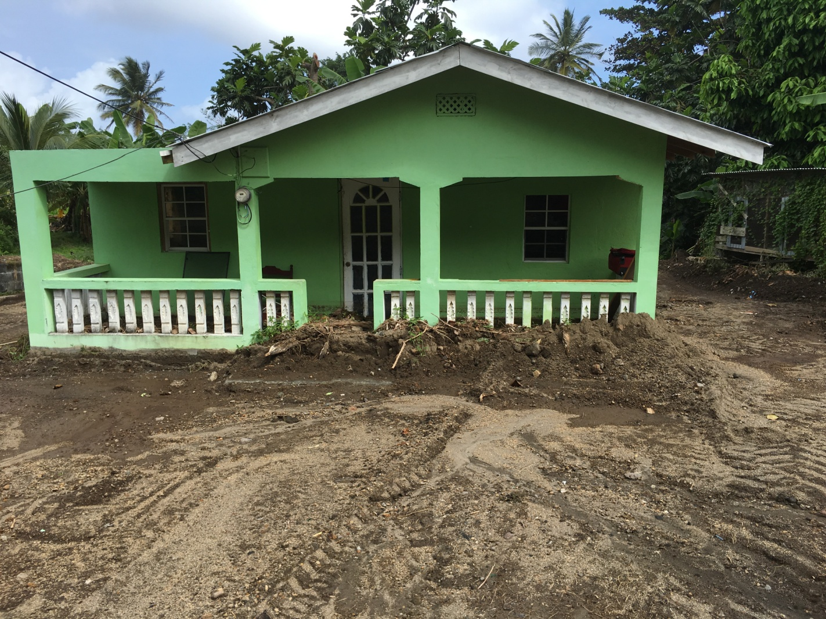

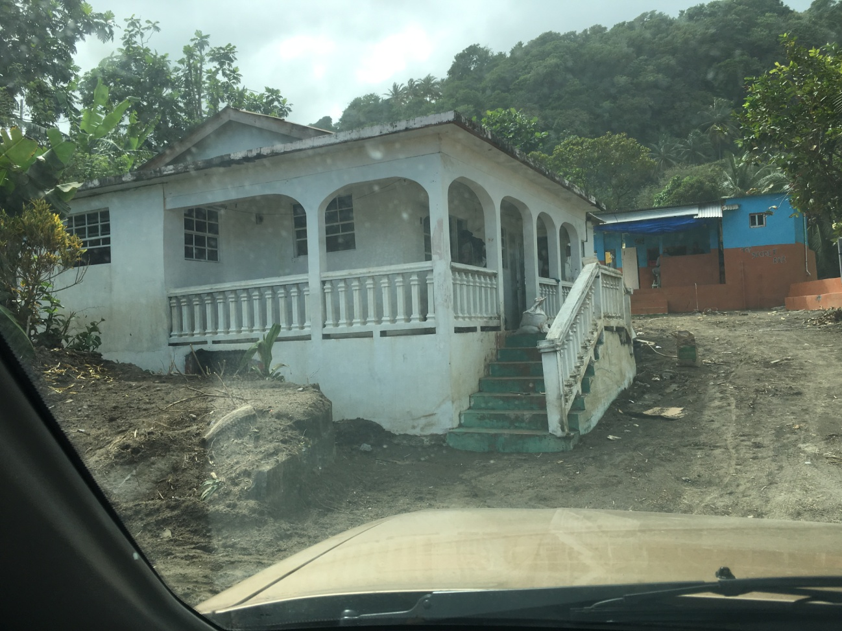

 much anticipation from all quarters. There is already great expectations from this project and will need all of your support in the future. Details of the charter arrangements will be sent out during this week as final arrangements are being finalized.

While here, I visited the affected areas of Sandy Bay and Owia with several groups to hand out food and gifts to the residents of these areas. While those immediate needs are being attended to, I drove around to look at something we can do to assist the long term needs of the home owners affected.

Before I left Toronto, some good donors on this mail list sent money to the tune of CAN$250. I have decided to use that money to purchase paint to repaint two homes that were flooded. Several friends and business owners here have also agreed to join us on this project.

We will work along with the Lions Club South on this project.

I will be back on January 14 ready to continue our good work TOGETHER.

Again, wishing you and your family a Healthy and Prosperous 2017.

Regards

CG

"FITZ"  
___

**GHS Library: Please help if you can.**  
Donations can be made in person at the school or via  
 [www.gofundme.com/ghslibrary](http://www.gofundme.com/ghslibrary)  
Donations can be in the form of money or new fiction and non-fiction books.  
__  
SCHOLARSHIP FUND : ISLAND SCHOLARS  
Thanks, Ron Rose, for this initiative and Celia Hadaway for sharing.  
Please assist.  All contributions are  tax-deductible. Thanks.

I have met a fellow Vincentian who has set up a non profit for local kids. He operates out of the U.S. And I quite appreciate and respect his efforts.  I have forwarded you the email he had sent to me explaining what he does and a link to his website . I thought it a good idea to bring it to the attention of other Vincentians who are overseas and or living here, in the event they would be interested in support him.

I leave the decision to you to decide if it is something you would want to promote and pass on.

Celia Hadaway

Begin forwarded message:

**From:** Celia Hadaway <[harmonycondos@gmail.com](mailto:harmonycondos@gmail.com)>  
**Subject:** **Fwd: Island Scholars**

Begin forwarded message:

**From:** Ron Rose <[islandscholars@gmail.com](mailto:islandscholars@gmail.com)>  
**To:** Celia Hadaway <[harmonycondos@gmail.com](mailto:harmonycondos@gmail.com)>  
**Subject:** **Island Scholars**  
2015

Dear Celia,

I founded Island Scholars Inc. in 2014 to provide financial support for highly motivated and ambitious Vincentian students who would have great difficulty attending university without significant financial aid.   
  
During my recent visit to St. Vincent and the Grenadines I had the privilege of interviewing students who applied for a scholarship. I shed a few tears listening to their stories of overcoming many challenges but excelling academically despite the obstacles. I was inspired by them.   
It was a resounding confirmation that the work of Island Scholars Inc. is desperately needed.  
  
This year we will award two scholarships of up to $16,000 each. Please help us raise funds so that next year we can double the amount awarded. Thank you for recruiting your friends to become Island Scholars supporters.  
  
<http://www.islandscholars.org/>  
Regards,

Ron Rose  
609-530-9462  
Thanks, also, to Cherrie Cuffy Hartley, for mentioning this worthwhile initiative.  
__  
KUDOS: Andrea Lewis, grand-daughter of Villager Carmen Phills.

You go, Andrea !! Thanks for the sentiments.  
[http://missandrealewis.com/2016/12/30/new-video-post-stepping-into-your-light](http://missandrealewis.com/2016/12/30/new-video-post-stepping-into-your-light/)

KUDOS: Sandy Bay School-Festus Toney Award-CHRISTMAS MUSIC FESTIVAL  
Congratulations to the Sandy Bay School. Thanks to The Vincentian for this report.  
<http://thevincentian.com/festus-toney-award-goes-to-sandy-bay-p12269-1.htm>

|  |  |
| --- | --- |
| [http://thevincentian.com/clients/thevincentian/12-22-2016-1-00-06-PM-1322992.jpg](http://thevincentian.com/festus-toney-award-goes-to-sandy-bay-p12269-1.htm) | [Festus Toney Award goes to Sandy Bay](http://thevincentian.com/festus-toney-award-goes-to-sandy-bay-p12269-1.htm)  thevincentian.com  Global Description |

MAGAZINE: All the best  
Yvonne Walker-Andrew

Tue 12/27/2016, 7:03 PM  
Season's Greetings and Happy New Year!

My niece, Chantal and friends are starting a new venture - a magazine (Meraki Creative).  Please view the details on the website below. You may also share with your family and friends.

<http://www.empowering-her.com/>

Fondest regards,

Yvonne

___

Fred Prescod

Tue 12/20/2016, 9:52 AM

Dis Time Nah Lang Time  
  
Back in time, remembering Guyanese parlance, places, and persons that we yearn to recreate. The way we were. Dis time nah lang time.  
[Dis Time Nah Lang Time](https://www.youtube.com/embed/AQWU12Eng4I)  
  
Kanchan - *Dis Time Na Long* *Time* (Chutney)  
<https://www.youtube.com/embed/xAaoC5353Bo>

**BIRTHDAYS, ANNIVERSARIES etc.**  
  
To those celebrating birthdays, anniversaries any other reasons to celebrate this month--have a good one.

**PRAYERS:**

To those facing health challenges we keep you in our prayers, especially

all on the list at:

<http://stpaulscalliaqua.homestead.com/rectormessage.html>

May you all soon be back to 100%.  
Those facing other challenges may you find relief and comfort.

**Thanks.**

**SYMPATHY:**

**To those who have recently lost loved ones please accept our deepest sympathy.**

May they rest in peace and may light perpetual shine upon them.

Our prayers are with those who mourn.

SIR DWIGHT VENNER PASSES 12/22/16: DR.THE HON. RALPH GONSALVES'

STATEMENT 12/23/16 API etc. Funeral January 4, 2017, at 2:00 p.m.

Sir Dwight will be sadly missed and remembered fondly. Condolences to the Jacobs/Venner families.

See:

<https://www.facebook.com/ECCBConnects/>

|  |
| --- |
| [ECCB Connects | Facebook](https://www.facebook.com/ECCBConnects/)  [www.facebook.com](http://www.facebook.com)  ECCB Connects, Bird Rock, St Kitts and Nevis. 234 likes · 19 talking about this. ECCB Connects is an outreach initiative of the Eastern Caribbean Central... |

The funeral service will be streamed live to ensure that all persons so desiring can participate. In this regard, the ECCB staff will assemble in the Sir Cecil Jacobs Auditorium from 1:45 p.m. Retirees, other ECCB alumni and friends are welcomed to attend.

__

I**N MEMORIAM: Alban "Uncle" Radix**

Yesterday, 1/1/2017, marked 50 years since the passing of lawyer Alban "Uncle" Radix.

Known as the "poor people's lawyer" he was a true trailblazer. He left his impact on the youth of the area in that era in a special way particularly as Scout Master. His influence can be seen and felt by the many under his tutelage who have led positive, successful lives and credit him for fostering their leadership abilities which have been applied wherever they have found themselves in the universe. May he rest in peace and may light perpetual shine upon him. "I say"..may his memory continue to bring a smile to your face.😊

Thanks for your messages.

All praise and thanks to God.

Love,

CK.

Give the gift of books:

Publications:

* "Introduction to Chemistry and the Environment" by Baldwin King (2002)
* "Michael Manley & Democratic Socialism : Political Leadership and Ideology in Jamaica" by Cheryl L. A. King (2003)
* "Search for Identity : Essays on St. Vincent & the Grenadines" edited by: Baldwin King, Kenneth John & Cheryl L. A. King (2006)
* "Quest for Caribbean Unity : Beyond Colonialism" edited by: Kenneth John, Baldwin King & Cheryl L. A. King (2006)
* "Home Sweet Home : Musings on Hairoun" edited by:
* Kenneth John, Baldwin King & Cheryl L. A. King (2007)
* "Pioneers in Nation-Building in a Caribbean Mini-State" by Sir Rupert John with a new foreword by Karl John Published by KINGS-SVG (2009)
* "Timescape and Other Caribbean Poems" by Dr. Lance Bannister and Marcia Harold Hinds. Published by KINGS-SVG (2009)
* "Caribbean Trailblazers: St.Vincent and the Grenadines" edited by: Baldwin King and Cheryl Phills King (2010) (Vol. 1 )
* "Spirit-Filled and Emancipated Living" by Laura Anthony Browne Published by KINGS-SVG (2010)
* "From Shakers To Spiritual Baptists: The Struggle For Survival of the Shakers of St. Vincent and the Grenadines" by Adrian Fraser Published by KINGS-SVG (2011)
* "Caribbean Trailblazers: St.Vincent and the Grenadines" Vol. 2 edited by: Baldwin King and Cheryl Phills King (2011)
* "Caribbean Trailblazers: St.Vincent and the Grenadines" Volumes I and 2 together edited by: Baldwin King and Cheryl Phills King (2012)
* "Christianity and Black Oppression: Duppy Know Who Fe Frighten " by Zay Green Published by KINGS-SVG (2012)
* "Caribbean Short Stories: Life Long Ago" by Rosa Veeta Published by KINGS-SVG (2013)
* "Caribbean Affair" by Veronica Davidson Published by KINGS-SVG (2014)
* "The Rise of a Spiritual Leader in St. Vincent and the Grenadines" by Phyllis Ralph Browne Published by KINGS-SVG (2016)  
    
  For more information about the above publications please contact:  
  Dr. Baldwin King at: [kingba@aol.com](mailto:kingba@aol.com)  
  "The International Encyclopedia of Revolution and Protest "  
  article entitled ""Manley, Michael (1924-1997)" by Cheryl L. A. King (2009)  
    
  Visit the Kings Website at: <http://www.kingsinn-svg.com/>